Bracket Tutorial Part 2: Analyze the bracket for strength

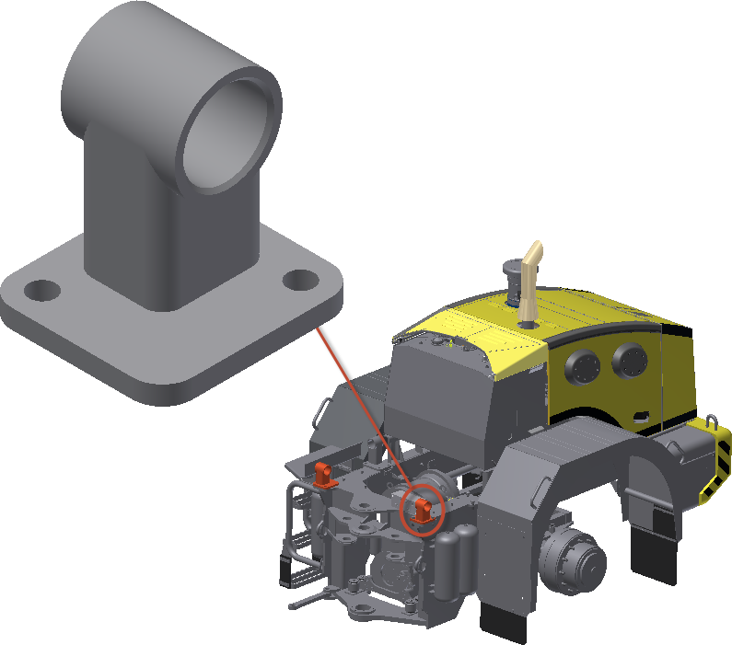

Tip: In a real world scenario, you would need the dimensions, weight, and Center of Gravity of the cab to do a free-body diagram. This exercise does not cover this procedure.

Task 1: Simulate the static weight of the cab:

- Apply a Fixed constraint to the bottom face of the mounting bracket.
- Apply a Bearing Load to the inner face of the tube in the negative Z direction (assuming Z is up.)
  - The magnitude of the Bearing Load depends on the weight of the cab (assume 4000 lbs). The Bearing Load would be ¼ of that or 1000 lbs. (This exercise assumes the cab weight is evenly distributed to all four cab mounting brackets).
Task 2: Simulate the Loader driving over rough terrain:

- Add a horizontal force to one of the end faces of the tube. Use a rough guess of 500 lbs.

